CS 3398: The Back Row

Software Architecture Document

prepared by:

Alec Meyer, Robert Padilla, Anthony Prejean, james kubena, and britton ware

2015

# **Introduction**

* 1. **Purpose**
     1. This document’s purpose is to deliver a broad architectural overview of the MCS 593 Tutorial Management Web Application. The intention of this document is to express the significant architectural conclusions which have been made on the system.
  2. S**cope of Document**
     1. The MCS 593 Tutorial Management Web Application is being developed by the Back Row team and is being designed to support the tutoring lab located in MCS 593. All architectural drawings for this document are directly built to purpose this system.
  3. **Architectural Representation of System**
     1. This document includes the following UML style architectural views: Logical, Process, Development, and the +1 Use Case View.
     2. The physical view is out of the scope for this project.
  4. **Architectural Goals and Constraints**
     1. Some key requirements both functional and nonfunctional have important bearing on the architectural design. For example:
        1. System must be able to accept data formats of legacy DBMS of CS students.
        2. Systems must have a stable internet connection.
        3. The Tutoring System must ensure protection of data from unauthorized users.
        4. The Tutoring System will be implemented as a client-server system. The server system will reside in Texas State’s Datacenter and the client’s will supply devices to connect to the web interface.
        5. Performance requirements and data integrity requirements as outlined in the Software Requirements and Specifications document. [4]
  5. **Use-Case View**
     1. Description of Use-Case view of this software architecture. This view is important to the tutoring system as it goes through the different types of scenarios the end-user and tutors will experience when interacting with the software system.
        1. Login
        2. Tutoring session scheduling
        3. Tutoring session cancellation
     2. These use cases for this system will be initiated by the students. Tutors will have access to interact and cancel student’s sessions.
  6. **Significant Architectural Use-Cases**

**1.6.1**

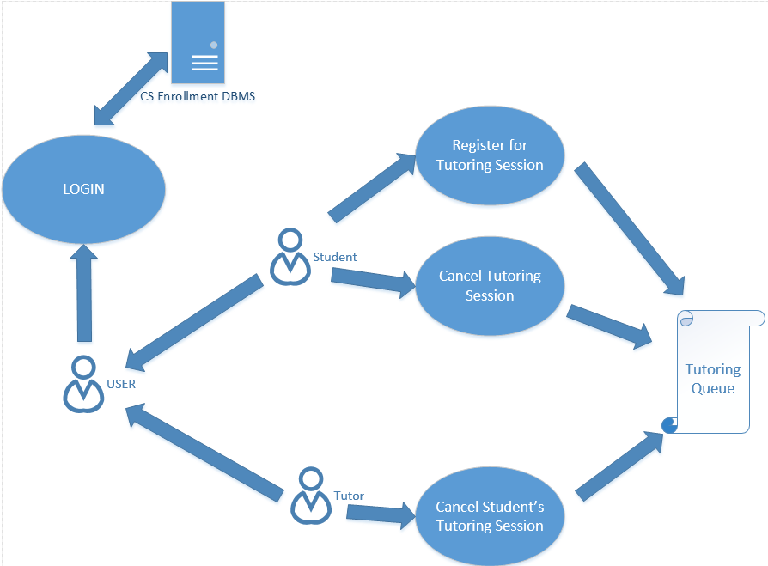

* 1. **Process View**

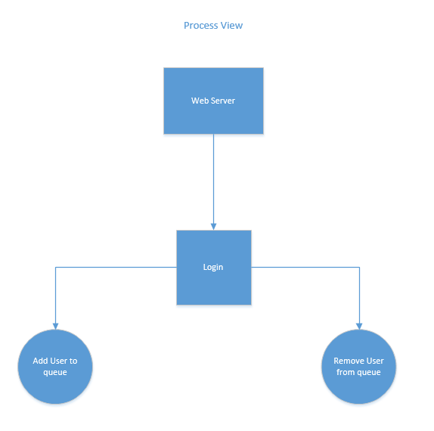

* 1. **Logical View**
     1. 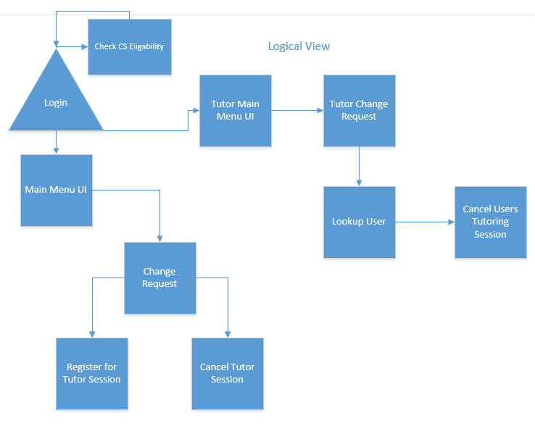
  2. **Development View**
     1. 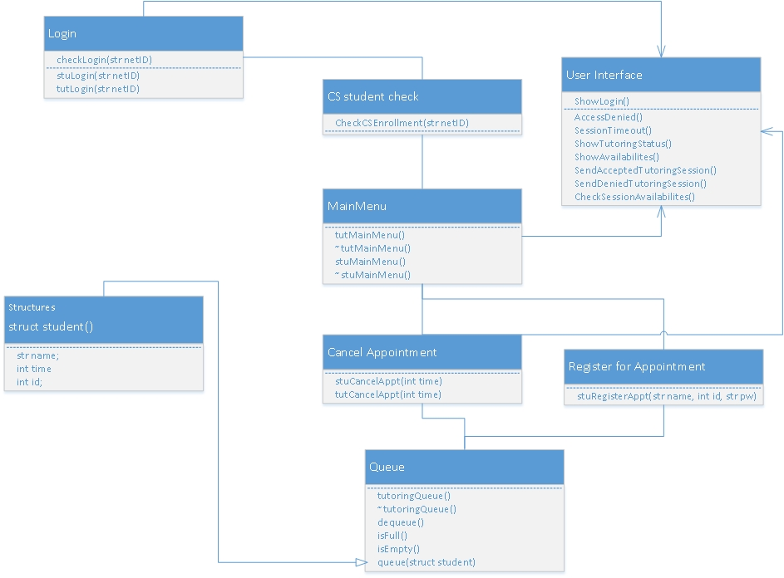

**2.0 External Resources**

**2.1** [**http://www.stg.tu-darmstadt.de/media/st/teaching/courses/ws2009/material_eise/20091202b_logicalarchitecture.pdf**](http://www.stg.tu-darmstadt.de/media/st/teaching/courses/ws2009/material_eise/20091202b_logicalarchitecture.pdf)

**2.2** [**http://sebokwiki.org/wiki/Logical_Architecture_Design**](http://sebokwiki.org/wiki/Logical_Architecture_Design)